**Moodboard**

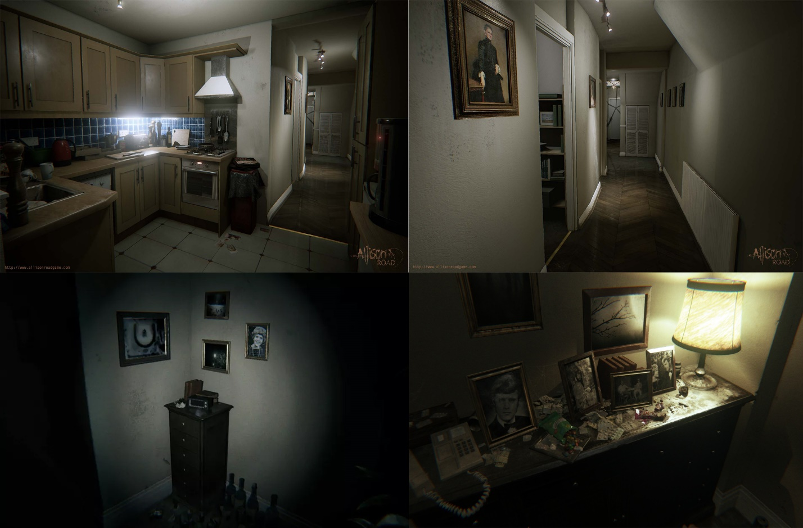

Psychological horror atmosphere

Closed spaces (Inside apartment / building)

Dark and gritty lighting

High poly

Realistic

**Work process**

|  |  |  |  |  |
| --- | --- | --- | --- | --- |
| **Asset List** | | | | |
| **Asset** | **Started** | **Ready for texturing** | **Textured** | **Completed** |
| Apartment   * Floor * Wall * Window * Door * Ceiling | **-**  **X**  **X**  **-**  **-**  **-** | **-**  **X**  **X**  **-**  **-**  **-** | **-**  **X**  **X**  **-**  **-**  **-** | **-**  **X**  **X**  **-**  **-**  **-** |
| Picture Frame | **-** | **-** | **-** | **-** |
| Telephone (landline) | **-** | **-** | **-** | **-** |
| Cabinet | **X** | **X** | **X** | **90%** |
| Bookcase | **-** | **-** | **-** | **-** |
| Book | **-** | **-** | **-** | **-** |
| Carpet | **-** | **-** | **-** | **-** |
| Radio / Alarmclock | **-** | **-** | **-** | **-** |
| Ashtray | **-** | **-** | **-** | **-** |
| Wine Glass | **X** | **X** | **X** | **X** |
| Wine Bottle | **-** | **-** | **-** | **-** |
| Desk Light | **X** | **X** | **-** | **-** |
| TV | **-** | **-** | **-** | **-** |
| Table | **X** | **X** | **X** | **X** |
| Couch | **X** | **-** | **-** | **-** |
| Chair | **-** | **-** | **-** | **-** |
| Cardboard Box | **X** | **X** | **X** | **X** |
| Mirror | **X** | **X** | **X** | **X** |
| Bucket | **X** | **X** | **X** | **X** |